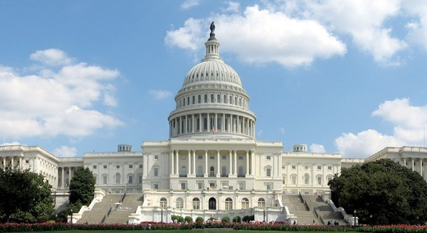
Congressional Project

Background: For the next few weeks you will be completing a project that will give you an in-depth look at the Legislative Branch. During this time, our classroom will be transformed into one of the two houses of Congress; the House of Representatives (Smith) or the Senate (Smalley). To help us with this transformation, each student will become a Congressperson that will try to write and pass bills. This project is a serious fun way of learning more about the “People’s Branch.”
Key Dates:
Mon/Tues November 10/11: How a bill becomes law internet activity, DUE NEXT CLASS
Wed/Thus Nov 12/13: Questions about internet activity, Introduction to the Congressional Project, Profile assignment, Be ready to work on STEP 1 next class
Fri/Mon Nov. 14/17: Profile work and research, time to complete Profile.
PROFILE IS DUE IN THE BEGGING OF NEXT CLASS (NOV. 18/19).

Tues/Wed Nov 18/19: How to write a Bill. Time to Find and start Writing your Bill.
Thus/Fri 20/21: Finish writing your bill, Due by Midnight Saturday Night the 22nd
csmalley@rfschools.com mailto:wsmith@rfschools.com

THANKSGIVING BREAK!!

Mon/Tues Dec 1/2: Bills in Committee. Debate and argue Bills.

Wed- Monday Dec 3/4 AND 5/8: Debate and argue Bills, whole class.

Fri/Mon Dec 9/10: Receive and vote on Bills from the other side of Congress.
VOTING RECORD IS DUE AT THE BEGINNING OF CLASS THURS/FRI 11/12.

You will receive 4 grades during this project
- Congressional Profile Grade
- Bill Grade
- Four participation/discussion grades
- Voting Record Grade (x4), they will get averaged together

STEP 1. Creating Your “Congressional Profile”
You will be randomly assigned a political party and a state that you will become a senator (Smalley) or representative (Smith) from. You will research and write up a profile that should guide your decisions on bills.
You can “make up” information for your congressional profile but it would probably be helpful to research either a senator or representative from the state and party that you drew to give you some ideas. You can got to either the house website: www.house.gov or the senate website www.senate.gov to research a senator of representative to base your profile on.

STEP 2: Creating Your Bills
This step of our simulation is perhaps the most important aspect of being a member of Congress. Your goal is to write a bill that will become law. When creating these bills, try to think of something that you are really passionate about and would like to see become a law. You should also consider your research on your state and the needs and wants of your constituents.

STEP 3: Discussing, editing and voting on the Bills
In this final stage, your bill will be put through the ringer! It will first be discussed in your committee, then in the full class, and if it passes through to the opposite house, in the other class.

STANDARD | 4 | 3 | 2 | 1
Engage in Civic activities | Student is able to discuss and elaborate on the bill. They are voluntarily and politely engaged in discussions. Student adds comments and questions to the discussion, and can reference the materials to support ideas. The information added is thoughtful. Student may seem to be the “leader” of the committee and discussions. | Student needs minimal cues or prompting to join the discussion. Student can elaborate on ideas when prompted, and frequently references the materials to support ideas. Student appears to be an active member of the group. | Student can discuss with cues and prompts. There is minimal elaboration, and minimal reference to the materials. Student appears to be on the “outskirts” of the group. | Student participates only minimally (once, or not at all), or it is obvious that the student is guessing at answers and has not read the bill. They are not engaged with the discussion.

